**APLIKASI GUI PEDETEKSI BANJIR**

**Nama : Anastasya Br Ginting(311910528)**

Matlab menyediakan fasilitas untuk membuat suatu program yang dibuat agar tampilannya lebih menarik. Sebagai contoh adalah pembuatan simulasi fisika sederhana. Kita dapat membuat tampilan agar lebih interaktif dan menarik sehingga membantu kita dalam memahami apa yang sedang disimulasikan. Fasilitas ini disebut dengan GUI (Graphical User Interface).

1. Untuk membuat GUI kita dapat mengetik ‘guide’ pada command window matlab

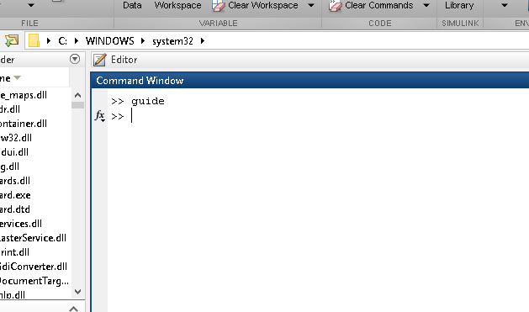

1. Kemudian akan muncul kotak dialog berikut ini

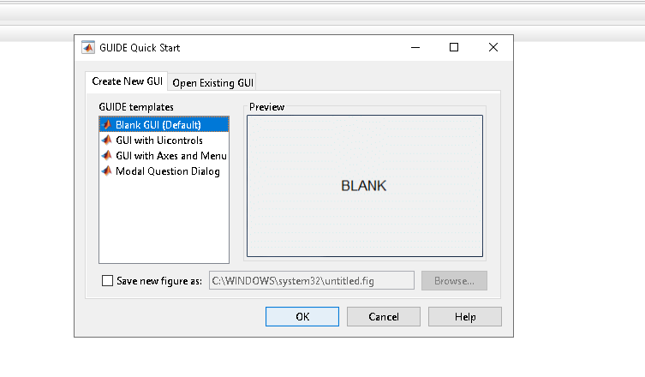

1. Kita pilih ‘Blank GUI (Default)’ dan akan muncul gambar berikut ini

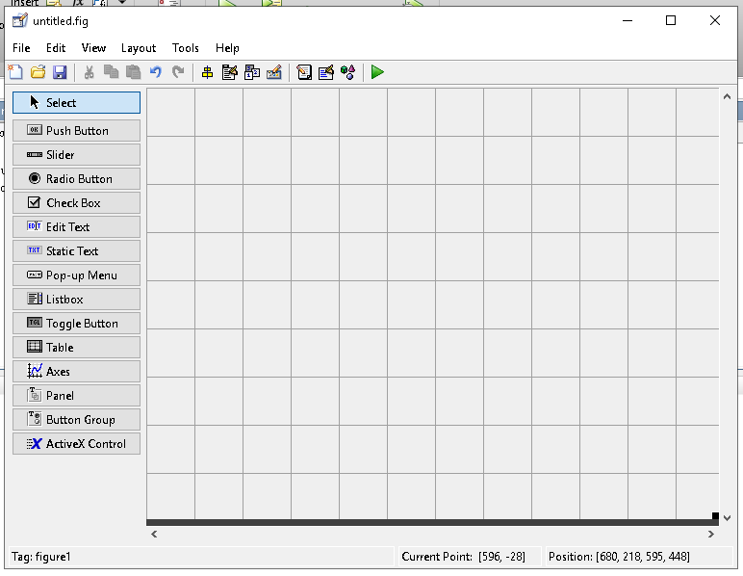

Disinilah kita akan meletakkan komponen-komponen yang digunakan untuk membuat program. Sebelum kita membuat program sebaiknya kita mengenal dahulu apa saja komponen yang ada pada GUI tersebut. Berikut ini nama-nama komponen pada GUI di atas

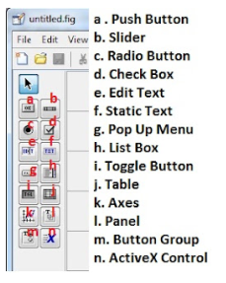

Sekarang mari kita buat suatu tampilan untuk Desain Pediteksi Banjir. Desain tampilan tidak bersifat mutlak, terserah kepada pembuat programnya. Berikut ini tampilan yang saya buat

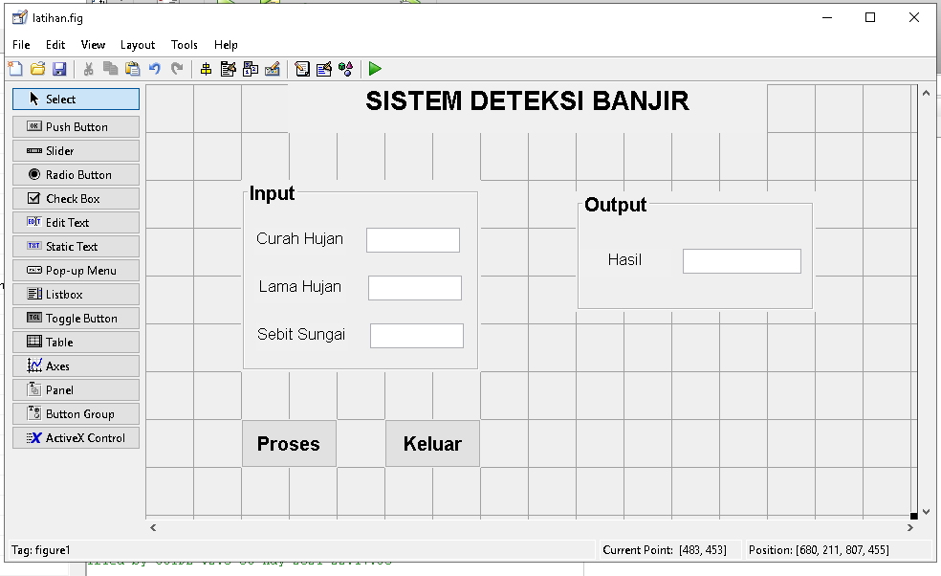

Bagian yang dilingkari adalah bagian yang penting dalam penulisan kode program. Untuk itu kita langsung saja praktekkan. Pada tampilan yang saya buat klik kanan pada tombol hitung, kemudian pilih view callbacks, dan pilih callback. Maka akan tampak tampilan berikut ini

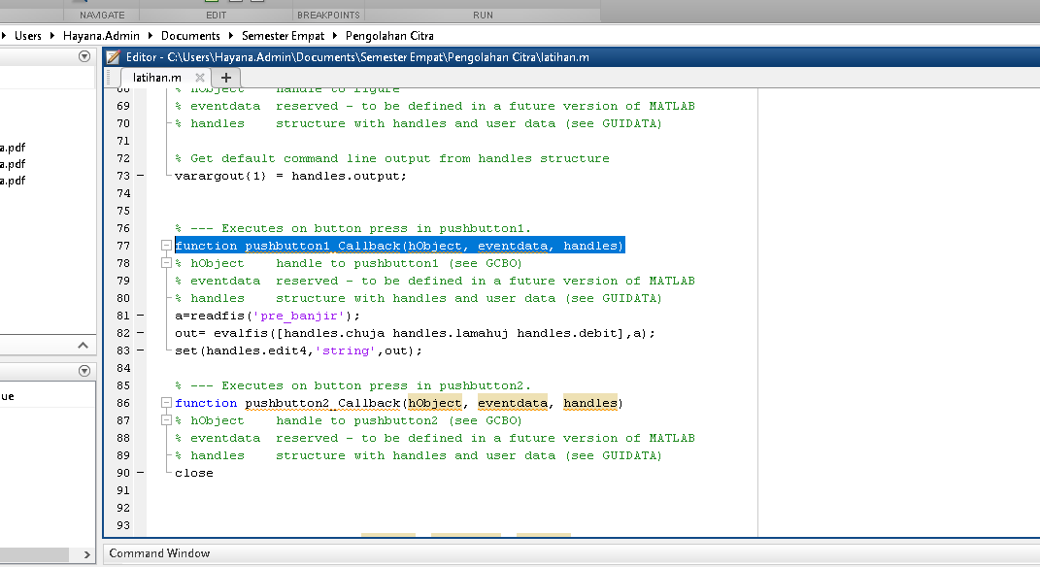

* Kode Program pushbutton1 (Proses)

a=readfis('pre_banjir');

out= evalfis([handles.chuja handles.lamahuj handles.debit],a);

set(handles.edit4,'string',out);

* Kode Program Edit 1 (Curah Hujan)

chuja=str2double(get(hObject,'string'));

handles.chuja=chuja;

guidata(hObject,handles);

* Kode Program Edit 2 (Lama Hujan)

lamahuj=str2double(get(hObject,'string'));

handles.lamahuj=lamahuj;

guidata(hObject,handles);

* Kode Program Edit 3 (Debit Sungai)

debit=str2double(get(hObject,'string'));

handles.debit=debit;

guidata(hObject,handles);

* Kode Program pushbutton2(keluar)

Close

**Maka Hasil Setelah Di RUN**

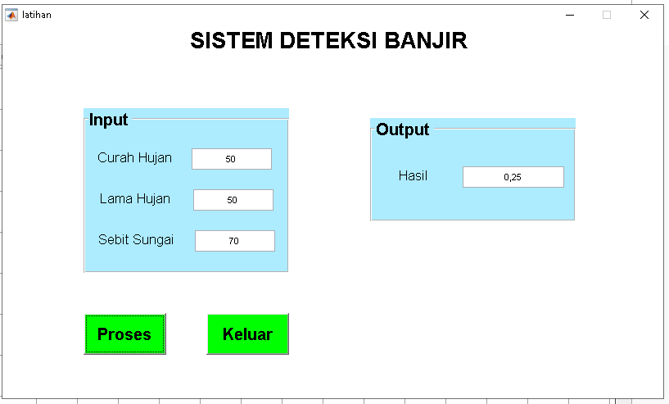

function varargout = latihan(varargin)

% LATIHAN MATLAB code for latihan.fig

% LATIHAN, by itself, creates a new LATIHAN or raises the existing

% singleton*.

%

% H = LATIHAN returns the handle to a new LATIHAN or the handle to

% the existing singleton*.

%

% LATIHAN('CALLBACK',hObject,eventData,handles,...) calls the local

% function named CALLBACK in LATIHAN.M with the given input arguments.

%

% LATIHAN('Property','Value',...) creates a new LATIHAN or raises the

% existing singleton*. Starting from the left, property value pairs are

% applied to the GUI before latihan_OpeningFcn gets called. An

% unrecognized property name or invalid value makes property application

% stop. All inputs are passed to latihan_OpeningFcn via varargin.

%

% *See GUI Options on GUIDE's Tools menu. Choose "GUI allows only one

% instance to run (singleton)".

%

% See also: GUIDE, GUIDATA, GUIHANDLES

% Edit the above text to modify the response to help latihan

% Last Modified by GUIDE v2.5 06-May-2021 22:37:07

% Begin initialization code - DO NOT EDIT

gui_Singleton = 1;

gui_State = struct('gui_Name', mfilename, ...

'gui_Singleton', gui_Singleton, ...

'gui_OpeningFcn', @latihan_OpeningFcn, ...

'gui_OutputFcn', @latihan_OutputFcn, ...

'gui_LayoutFcn', [] , ...

'gui_Callback', []);

if nargin && ischar(varargin{1})

gui_State.gui_Callback = str2func(varargin{1});

end

if nargout

[varargout{1:nargout}] = gui_mainfcn(gui_State, varargin{:});

else

gui_mainfcn(gui_State, varargin{:});

end

% End initialization code - DO NOT EDIT

% --- Executes just before latihan is made visible.

function latihan_OpeningFcn(hObject, eventdata, handles, varargin)

% This function has no output args, see OutputFcn.

% hObject handle to figure

% eventdata reserved - to be defined in a future version of MATLAB

% handles structure with handles and user data (see GUIDATA)

% varargin command line arguments to latihan (see VARARGIN)

% Choose default command line output for latihan

handles.output = hObject;

% Update handles structure

guidata(hObject, handles);

% UIWAIT makes latihan wait for user response (see UIRESUME)

% uiwait(handles.figure1);

% --- Outputs from this function are returned to the command line.

function varargout = latihan_OutputFcn(hObject, eventdata, handles)

% varargout cell array for returning output args (see VARARGOUT);

% hObject handle to figure

% eventdata reserved - to be defined in a future version of MATLAB

% handles structure with handles and user data (see GUIDATA)

% Get default command line output from handles structure

varargout{1} = handles.output;

% --- Executes on button press in pushbutton1.

function pushbutton1_Callback(hObject, eventdata, handles)

% hObject handle to pushbutton1 (see GCBO)

% eventdata reserved - to be defined in a future version of MATLAB

% handles structure with handles and user data (see GUIDATA)

a=readfis('pre_banjir');

out= evalfis([handles.chuja handles.lamahuj handles.debit],a);

set(handles.edit4,'string',out);

% --- Executes on button press in pushbutton2.

function pushbutton2_Callback(hObject, eventdata, handles)

% hObject handle to pushbutton2 (see GCBO)

% eventdata reserved - to be defined in a future version of MATLAB

% handles structure with handles and user data (see GUIDATA)

close

function edit4_Callback(hObject, eventdata, handles)

% hObject handle to edit4 (see GCBO)

% eventdata reserved - to be defined in a future version of MATLAB

% handles structure with handles and user data (see GUIDATA)

% Hints: get(hObject,'String') returns contents of edit4 as text

% str2double(get(hObject,'String')) returns contents of edit4 as a double

% --- Executes during object creation, after setting all properties.

function edit4_CreateFcn(hObject, eventdata, handles)

% hObject handle to edit4 (see GCBO)

% eventdata reserved - to be defined in a future version of MATLAB

% handles empty - handles not created until after all CreateFcns called

% Hint: edit controls usually have a white background on Windows.

% See ISPC and COMPUTER.

if ispc && isequal(get(hObject,'BackgroundColor'), get(0,'defaultUicontrolBackgroundColor'))

set(hObject,'BackgroundColor','white');

end

function edit1_Callback(hObject, eventdata, handles)

% hObject handle to edit1 (see GCBO)

% eventdata reserved - to be defined in a future version of MATLAB

% handles structure with handles and user data (see GUIDATA)

chuja=str2double(get(hObject,'string'));

handles.chuja=chuja;

guidata(hObject,handles);

% Hints: get(hObject,'String') returns contents of edit1 as text

% str2double(get(hObject,'String')) returns contents of edit1 as a double

% --- Executes during object creation, after setting all properties.

function edit1_CreateFcn(hObject, eventdata, handles)

% hObject handle to edit1 (see GCBO)

% eventdata reserved - to be defined in a future version of MATLAB

% handles empty - handles not created until after all CreateFcns called

% Hint: edit controls usually have a white background on Windows.

% See ISPC and COMPUTER.

if ispc && isequal(get(hObject,'BackgroundColor'), get(0,'defaultUicontrolBackgroundColor'))

set(hObject,'BackgroundColor','white');

end

function edit2_Callback(hObject, eventdata, handles)

% hObject handle to edit2 (see GCBO)

% eventdata reserved - to be defined in a future version of MATLAB

% handles structure with handles and user data (see GUIDATA)

lamahuj=str2double(get(hObject,'string'));

handles.lamahuj=lamahuj;

guidata(hObject,handles);

% Hints: get(hObject,'String') returns contents of edit2 as text

% str2double(get(hObject,'String')) returns contents of edit2 as a double

% --- Executes during object creation, after setting all properties.

function edit2_CreateFcn(hObject, eventdata, handles)

% hObject handle to edit2 (see GCBO)

% eventdata reserved - to be defined in a future version of MATLAB

% handles empty - handles not created until after all CreateFcns called

% Hint: edit controls usually have a white background on Windows.

% See ISPC and COMPUTER.

if ispc && isequal(get(hObject,'BackgroundColor'), get(0,'defaultUicontrolBackgroundColor'))

set(hObject,'BackgroundColor','white');

end

function edit3_Callback(hObject, eventdata, handles)

% hObject handle to edit3 (see GCBO)

% eventdata reserved - to be defined in a future version of MATLAB

% handles structure with handles and user data (see GUIDATA)

debit=str2double(get(hObject,'string'));

handles.debit=debit;

guidata(hObject,handles);

% Hints: get(hObject,'String') returns contents of edit3 as text

% str2double(get(hObject,'String')) returns contents of edit3 as a double

% --- Executes during object creation, after setting all properties.

function edit3_CreateFcn(hObject, eventdata, handles)

% hObject handle to edit3 (see GCBO)

% eventdata reserved - to be defined in a future version of MATLAB

% handles empty - handles not created until after all CreateFcns called

% Hint: edit controls usually have a white background on Windows.

% See ISPC and COMPUTER.

if ispc && isequal(get(hObject,'BackgroundColor'), get(0,'defaultUicontrolBackgroundColor'))

set(hObject,'BackgroundColor','white');

end